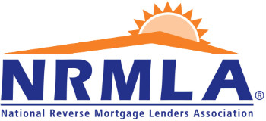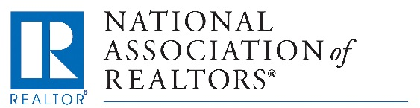
Dear Colleague,
I am writing to let you know about an upcoming webcast from the National Association of Realtors that will explain how real estate agents can work with senior home buyers who may benefit from using a reverse mortgage to purchase a home. The free webcast will feature interviews with a Realtor who has successfully helped dozens of clients buy homes in Myrtle Beach, SC. The webcast will be live on February 22, at 2pm ET and you do not need to be a member of NAR to register. More information about the webinar is below and you can register for free online.
Please don’t hesitate to contact me with questions,
YOUR NAME
Buying a home without signing on for a monthly mortgage payment typically means an all-cash purchase, but for homebuyers aged 62 and older, there’s another financing option – FHA’s Home Equity Conversion Mortgage (HECM) for Purchase program. With this option, a buyer who makes a significant down payment can finance the rest of the purchase price with a reverse mortgage loan that does not need to be repaid until the buyer permanently leaves the home.
HECM for Purchase offers a solution for older adults who are moving out of a home that no longer meets their needs - perhaps it is time to downsize from the family home, move to a warmer climate, "right size" into a house with features that can support aging in place, or retire comfortably in a home they've been dreaming of their whole lives.
Real estate agents who work with retired and nearly-retired homebuyers can learn more about HECM for Purchase during a free webcast hosted by the National Association of Realtors on February 22, at 2:00pm ET.
Real estate pro Scott Trembley and Frank McInerney, a loan originator and member of the National Reverse Mortgage Lenders Association, will explain HECM for Purchase and share practical advice for introducing this tool to buyers.
What: Live Webcast “Buying a Home with a Reverse Mortgage”
Who: Host Jon Boughtin, NAR Media Communications
- Scott Trembley, CEO of The Trembley Group, a real estate firm in Myrtle Beach, S.C., that handles home purchases with HECMs
- Frank McInerney, NRMLA member and loan specialist with Reverse Mortgage Funding, LLC
When: Feb. 22, 2:00pm ET
REGISTER: Free Online Registration
You do not need to be a member of the National Association of Realtors to register for this webcast

