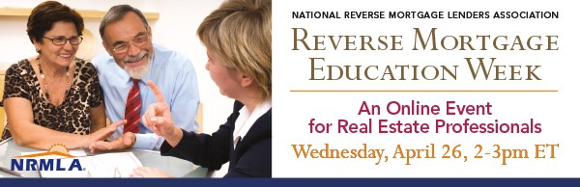
NRMLA's Reverse Mortgage Education Week is dedicated to teaching professionals who work with seniors how reverse mortgage loans work and how a HECM can help meet their clients' financial needs.
On Wednesday, April 26, NRMLA will present “A Financial Option for Senior Homebuyers: Understanding HECM for Purchase,” an informational webinar for real estate professionals. NRMLA Education Committee Co-Chair Jim Cory, CRMP, and David Heilman, CRMP, will explain the process for using a reverse mortgage to purchase a home and provide examples of how buyers, and sellers, can benefit from H4P.
If you know real estate professionals who work with buyers over the age of 62, please encourage them to register for this free webinar.
What: Webinar: A Financial Option for Senior Homebuyers: Understanding HECM for Purchase
When: April 26, 2017, 2:00 - 3:00 PM ET
Registration: https://attendee.gotowebinar.com/register/8165290388439446785
Here's a sample note you can share with the real estate professionals you know.
Dear Colleague,
I'm writing to let you know about an online educational session for real estate professionals that may interest you and your senior homebuyers aged 62 and over. On Wednesday, April 26th, the National Reverse Mortgage Lenders Association will lead a free webinar about using a reverse mortgage to purchase a home in conjunction with its Education Week that runs from April 24th-28th.
As you know, buying a home without signing on for a monthly mortgage payment typically means an all-cash purchase, but for homebuyers aged 62 and older, there’s another financing option – FHA’s Home Equity Conversion Mortgage (HECM) for Purchase program. With this option, a buyer who makes a significant down payment can finance the rest of the purchase price with a reverse mortgage loan that does not need to be repaid until the buyer permanently leaves the home.
HECM for Purchase offers a solution for older adults who are moving out of a home that no longer meets their needs - perhaps it is time to downsize from the family home, move to a warmer climate, "right size" into a house with features that can support aging in place, or retire comfortably in a home they've been dreaming of their whole lives.
For more background on reverse mortgage loans and HECM for Purchase, take a look at recent media coverage that shows how the responsible use of a reverse mortgage can enhance a retirement plan:
- Wall Street Journal: A Reverse Mortgage to Buy a Home? Here’s How
- US News and World Report: Should Retirees Buy a Home with a Reverse Mortgage?
- CBS News: "A Smart Way for Seniors to Tap Home Equity"
- Chicago Tribune: “Can a Reverse Mortgage Stabilize a Wobbly Retirement-Income Stool?”
- Forbes: “Using a Reverse Mortgage in a Responsible Retirement Income Plan”
- Kiplinger: “Why Reverse Mortgages are Worth a Look”
If you work with retired and nearly-retired homebuyers, NRMLA’s webinar will be well worth your time.
What: Webinar: “A Financial Option for Senior Homebuyers: Understanding HECM for Purchase.”
When: April 26, 2017, 2:00 - 3:00 PM ET
Free Registration: https://attendee.gotowebinar.com/register/8165290388439446785
If you have questions before or after the event, I’d be happy to meet with you to provide additional information.
Thank you,

