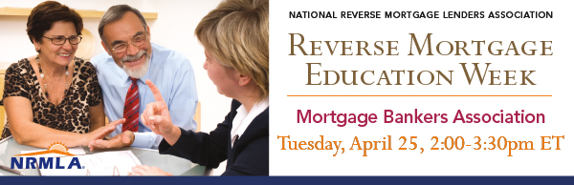
NRMLA's Reverse Mortgage Education Week is dedicated to teaching professionals who work with seniors how reverse mortgage loans work and how a HECM can help meet their clients' financial needs.
On Tuesday, April 25, reverse mortgage industry experts from four NRMLA member companies will present a 90 minute webinar to member of the Mortgage Bankers Association and interested lenders about developments and opportunities in the reverse mortgage lending space.
Speakers will address the need for reverse mortgages in light of an aging workforce, the process and fundamentals of reverse mortgages, and additional training opportunities for those handling these types of loans. This webinar will be beneficial to those currently offering reverse mortgage products as well as those who are considering entering the space. For those lenders who are currently not offering reverse mortgages, panelists will help them think through the approaches and questions that need to be considered.
If you know a mortgage professional who currently originates reverse mortgages, or who is interested in learning more about the reverse space, please encourage them to register for this event on the Mortgage Banker Association's website: https://www.mba.org/store/events/webinar/expanding-your-product-offerings-with-reverse-mortgages
What: NRMLA/MBA Webinar: Expanding Your Product Offerings with Reverse Mortgages
When: April 25, 2017, 2:00 - 3:30 PM ET
Registration: https://www.mba.org/store/events/webinar/expanding-your-product-offerings-with-reverse-mortgages
Speakers:
Tabatha Addison
Vice President, Business Development & Training, Wholesale Lending, American Advisors Group
Candra Adams
Manager, Operational Controls, Reverse Originations, Liberty Home Equity Solutions
Lorraine Geraci
Vice President, Learning and Development, Finance of America Reverse
Mark O'Neil
National Sales Leader, Wholesale & Correspondent, Reverse Mortgage Funding LLC
Here's a sample note you can share with the mortgage professionals you know.
Dear Colleague,
I'm writing to let you know about an online educational session for mortgage industry professionals that may interest you as you consider the suite of mortgage loan products you offer your clients, particularly seniors. On Tuesday, April 25, the National Reverse Mortgage Lenders Association is partnering with the Mortgage Bankers Association to lead a webinar about reverse mortgages in conjunction with its Education Week that runs from April 24th-28th.
Speakers will address the need for reverse mortgages in light of an aging workforce, the process and fundamentals of reverse mortgages, and additional training opportunities for those handling these types of loans. This webinar will be beneficial to those currently offering reverse mortgage products as well as those who are considering entering the space. For those lenders who are currently not offering reverse mortgages, panelists will help them think through the approaches and questions that need to be considered.
For more background on reverse mortgage loans and current industry trends, take a look at recent media coverage that shows how the responsible use of a reverse mortgage can enhance a retirement plan and help fund longevity:
- CBS News: "A Smart Way for Seniors to Tap Home Equity"
- Chicago Tribune: “Can a Reverse Mortgage Stabilize a Wobbly Retirement-Income Stool?”
- Forbes: “Using a Reverse Mortgage in a Responsible Retirement Income Plan”
- Wall Street Journal: “If You're Behind on Retirement Savings, Here's How to Catch Up”
- Kiplinger: “Why Reverse Mortgages are Worth a Look”
If you’re interested in an update on the reverse industry and opportunities in the space, NRMLA’s webinar is worth your time. To register, visit the Mortgage Banker Association’s website (you do not have to be a member of MBA to register, but a registration fee applies).
If you have questions before or after the event, I’d be happy to meet with you to provide additional information.
Thank you,

