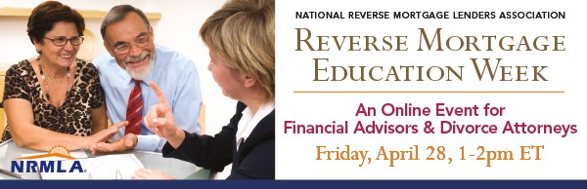
NRMLA's Reverse Mortgage Education Week is dedicated to teaching professionals who work with seniors how reverse mortgage loans work and how a HECM can help meet their clients' financial needs.
On Friday, April 28th at 1pm ET, NRMLA will present “Silver Divorce: Home Equity Strategies for Separating Spouses,” an informational webinar for financial advisors, divorce attorneys and mediators, and others who work with divorcing spouses.
If you know professionals who work with divorcing couples who are retired or nearly-retired, please encourage them to register for this free webinar.
What: Webinar: Silver Divorce: Home Equity Strategies for Separating Spouses
When: April 28, 2017, 1:00 - 2:00 PM ET
Registration: https://attendee.gotowebinar.com/register/9155244479117829634
Here's a sample note you can share with the financial advisors, divorce attorneys and mediators, and other interested professionals you know.
Dear Colleague,
I'm writing to let you know about an online educational session for financial advisors that may interest you and your older clients who are in the midst of a divorce. On Friday, April 28th, the National Reverse Mortgage Lenders Association will lead a free webinar about the unique financial considerations for silver divorces in conjunction with its Education Week that runs from April 24th-28th.
Silver divorce, sometimes called gray or mature divorce, is increasing in the U.S. where the divorce rate among couples 50 and older has roughly doubled since the 1990s. According to the Pew Research Center, silver divorcees tend to be less financially secure than married and widowed adults, particularly among women. And living alone at older ages can be detrimental to one’s financial comfort and, for men, their satisfaction with their social lives.

Older divorcing couples face unique financial challenges as they consider the division of marital assets and property, and they must pay particularly close attention to the impact a divorce will have on the retirement security of both spouses.
During this webinar for financial advisors, attorneys, and mediators, leading retirement income planning expert Jamie Hopkins of the American College of Financial Services will expound on his recent Forbes article that shows how divorcing spouses can use a reverse mortgage to help divide marital property.
Hopkins will be joined by Diane Pappas, a Certified Divorce Financial Analyst and Co-President of the Divorce Center, who will discuss the factors that should be evaluated when determining an equitable distribution of assets, explain Qualified Domestic Relations Orders and Domestic Relations Orders, and emphasize the importance of thinking creatively to meet clients’ needs.
NRMLA’s Education Committee Co-Chair Dan Hultquist will provide an overview of how reverse mortgage loans work, consumer protections for borrowers, and share examples of homeowners who have used a reverse mortgage to supplement retirement savings.
For more background on reverse mortgage loans, take a look at recent media coverage that shows how the responsible use of a reverse mortgage can enhance a retirement plan:
- CBS News: "A Smart Way for Seniors to Tap Home Equity"
- Chicago Tribune: “Can a Reverse Mortgage Stabilize a Wobbly Retirement-Income Stool?”
- Forbes: “Using a Reverse Mortgage in a Responsible Retirement Income Plan”
- Kiplinger: “Why Reverse Mortgages are Worth a Look”
If you work with retired or nearly-retired divorcing couples, NRMLA’s webinar will be well worth your time.
What: Webinar: Silver Divorce: Home Equity Strategies for Separating Spouses
When: April 28, 2017, 1:00 - 2:00 PM ET
Registration: https://attendee.gotowebinar.com/register/9155244479117829634
If you have questions before or after the event, I’d be happy to meet with you to provide additional information.
Thank you,

