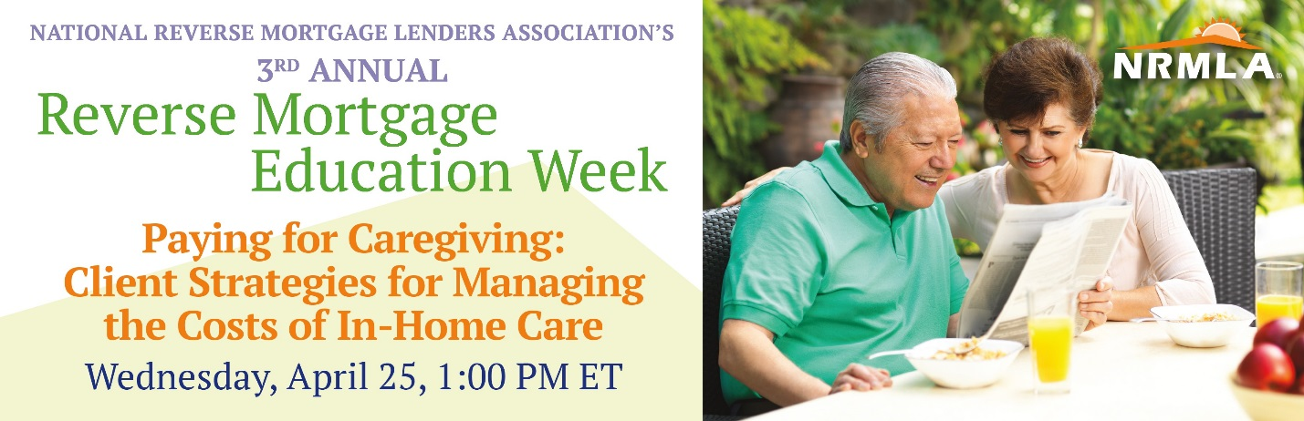
During Reverse Mortgage Education Week, the National Reverse Mortgage Lenders Association hosts a series of free informational webinars for older homeowners, their loved ones, and the professionals who serve them, to explain how the loans can be used to supplement retirement savings and support aging in place.
Most older adults would prefer to stay in their own homes as long as possible. But, they may require assistance from professional or family caregivers in order to safely, and comfortably, age in place. Both solutions come with costs that can be managed with financial options and resources available to seniors in need of in-home care including: Medicare, Medicaid, veterans benefits, private insurance, state and local programs, and the equity they have built up in their homes.
NRMLA is partnering with the American Society on Aging to educate their members, and non-member professionals who work with older adults, about the financial options available to their clients in need of home care services.
On April 25th, we will present, “Paying for Caregiving: Client Strategies for Managing the Costs of In-Home Care,” a free webinar featuring Nancy Avitabile, the owner of Urban Eldercare, an Aging Life Care practice in Manhattan, and president of the Aging Life Care Association, and Lorraine Geraci a reverse mortgage industry trainer and member of NRMLA’s Education Committee.
You can help NRMLA promote this free webinar by encouraging the home care professionals you know to register on the American Society on Aging’s website at: http://www.asaging.org/web-seminars/paying-caregiving-client-strategies-managing-costs-home-care
Here's a sample note you can share with the home care professionals you know.
Dear Friend,
I'm writing to let you know about an online educational session for professionals like you who provide services to older adults in their own homes. On Wednesday, April 25th, the National Reverse Mortgage Lenders Association is partnering with the American Society on Aging to host a free webinar called "Paying for Caregiving: Client Strategies for Managing the Costs of In-Home Care” in conjunction with its Education Week that runs from April 23rd-27th.
Most older adults would prefer to stay in their own homes for as long as possible, even when they require daily assistance. But finding the resources to pay for that in-home care can be a challenge. This web seminar is for professionals whose clients, and their loved ones, are searching for financial solutions to manage the costs of homecare.
Speakers Nancy Avitabile, owner and care manager at Urban Eldercare, and Lorraine Geraci, a member of the National Reverse Mortgage Lenders Association's Education Committee, will discuss financial resources and options your clients can use to pay for the care they need in their own homes.
Participants in this web seminar will be able to:
- Understand financial options and resources for clients can use to pay for non-medical homecare, depending upon their economic position and whether they rent or own their homes;
- Describe services Medicare, Medicaid and Veterans benefits will and will not cover;
- Recognize situations and circumstances when a client could benefit from using home equity to pay for care and for other purposes; and,
- Describe how reverse mortgages work, the features and responsibilities of the loan and the consumer protections for borrowers and their spouses.
It’s free participate in this webinar, and continuing education credits will be offered, but you must register in advance -here’s a link for more information: http://www.asaging.org/web-seminars/paying-caregiving-client-strategies-managing-costs-home-care
For more background on using home equity to supplement retirement savings, take a look at these articles and resources:
- Video Testimonial: Personal Financial Columnist Terry Savage Gets Personal
- ThinkAdvisor: “Reverse Mortgages Could Be Next Hot Topic in Retirement Planning”
- NRMLA: “Today’s Reverse Mortgages: Flexible with a lot of built in protections”
- Kiplinger: “Reverse Mortgages That Work”
- CBS News: "A Smart Way for Seniors to Tap Home Equity"
- Chicago Tribune: “Can a Reverse Mortgage Stabilize a Wobbly Retirement-Income Stool?”
- Forbes: “Using a Reverse Mortgage in a Responsible Retirement Income Plan”
- Wall Street Journal: “If You're Behind on Retirement Savings, Here's How to Catch Up”
- Kiplinger, “Why Reverse Mortgages are Worth a Look”
If your clients have questions about their options for financing the cost of homecare, NRMLA’s free webinar is worth your time.
If you have questions before or after the event, I’d be happy to meet with you to provide additional information.
Thank you,

Paying for Caregiving:
Client Strategies for Managing the Costs of In-Home Care
Wednesday, April 25, 1:00 PM ET • REGISTER
NRMLA is sponsoring a free webinar for the American Society on Aging to educate professionals who work with older adults about the financial tools and resources their clients can use to pay for in-home care. Continuing Education Credits will be offered.
Speakers: Nancy Avitabile, President Aging Life Care Association; Lorraine Geraci, NRMLA Education Committee
Free Registration: http://bit.ly/2FPucrh

