Subject: Paying for In-Home Care: A Free Webinar for You and Your Aging Parents
Most older adults would prefer to stay in their own homes as long as possible. But, they may require assistance from professional or family caregivers in order to safely, and comfortably, age in place. Both solutions come with costs that can be managed with financial options and resources available to seniors in need of in-home care including: Medicare, Medicaid, veterans benefits, private insurance, state and local programs, and the equity they have built up in their homes.
To explain the options, the National Reverse Mortgage Lenders Association is sponsoring a free webinar on Wednesday, April 25, at 3:00 PM ET / 12 NOON PT that you and your aging parents may find useful as you consider how to pay for in-home care. It is free to participate, but you must register in advance.
Paying for Caregiving:
Strategies for Managing the Costs of In-Home Care
Wednesday, April 25, 3:00 PM ET • FREE REGISTRATION
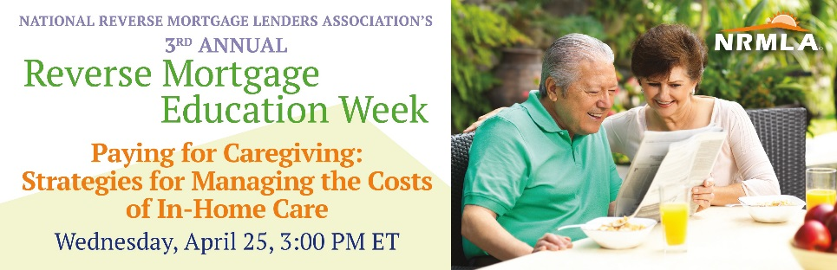
Speakers: Laura Giunta, CSA, President of Long Island Aging in Place Council; Kelli Vasquez, LCSW, Executive Director and Chief Population Health Officer of Square Care; Patty Wills, CRMP, NRMLA Education Committee
Free Registration: http://bit.ly/2IkbQAl
NRMLA is hosting these webinars as part of a series during the association’s 3rd Annual Reverse Mortgage Education Week. Learn more: https://www.reversemortgage.org/About-NRMLA/Reverse-Mortgage-Education-Week

