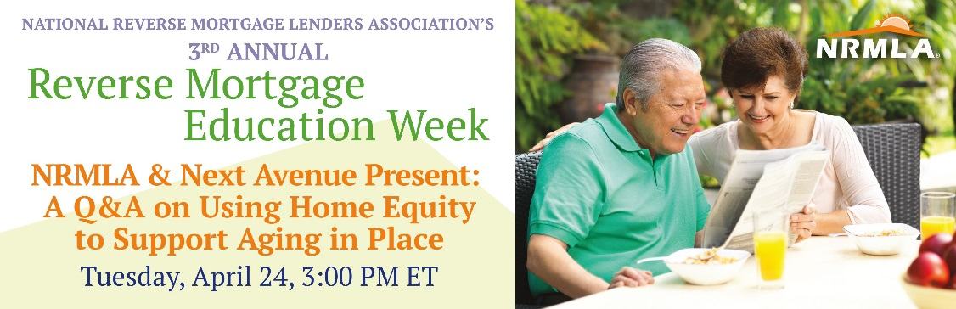
During Reverse Mortgage Education Week, the National Reverse Mortgage Lenders Association hosts a series of free informational webinars for older homeowners, their loved ones, and the professionals who serve them, to explain how the loans can be used to supplement retirement savings and support aging in place.
On April 24th at 3:00 PM ET, NRMLA and Next Avenue, the public media website for America’s booming older population, are partnering to host a free webinar Q&A with financial and home equity experts to answer consumer questions about incorporating home equity into a retirement financial plan. Experts will explain housing wealth and what the term home equity means, how it can be tapped, and situations when it may make sense to incorporate home equity into a retirement financial plan.
You can help NRMLA promote this free webinar by encouraging the older homeowners you know to register online on NRMLA’s consumer education website at: https://www.reversemortgage.org/About-NRMLA/Reverse-Mortgage-Education-Week/4-24-Using-Home-Equity-to-Support-Aging-in-Place
Here's a sample note you can share with the older homeowners you know.
Dear Friend,
I'm writing to let you know about an online educational session for homeowners like you who are considering tapping into your home equity to supplement retirement savings while still living in your own home. On Tuesday, April 24th, the National Reverse Mortgage Lenders Association is partnering with the public media website Next Avenue to lead an online Q&A webinar called "Using Home Equity to Support Aging in Place” in conjunction with its Education Week that runs from April 23rd-27th.
The free webinar will be moderated by Next Avenue editor Richard Eisenberg and feature financial and home equity experts from Blue Ocean Global Wealth, Magnify Money, the National Council on Aging, and the co-chair of NRMLA’s Education Committee. Speakers will:
- Answer consumer questions about using home equity to supplement retirement savings and support aging in place
- Explain housing wealth and what the term home equity means
- Identify methods and tools for tapping home equity including: home equity loans, home equity lines of credit, and reverse mortgages
- Describe situations when it may make sense to incorporate home equity into a retirement financial plan
It’s free participate in this webinar, but you must register in advance -here’s a link for more information: https://www.reversemortgage.org/About-NRMLA/Reverse-Mortgage-Education-Week/4-24-Using-Home-Equity-to-Support-Aging-in-Place
You can also submit your questions in advance by emailing Richard Eisenberg at: reisenberg@nextavenue.org
For more background on using home equity to supplement retirement savings, take a look at these articles and resources:
- Video Testimonial: Personal Financial Columnist Terry Savage Gets Personal
- ThinkAdvisor: “Reverse Mortgages Could Be Next Hot Topic in Retirement Planning”
- NRMLA: “Today’s Reverse Mortgages: Flexible with a lot of built in protections”
- Kiplinger: “Reverse Mortgages That Work”
- CBS News: "A Smart Way for Seniors to Tap Home Equity"
- Chicago Tribune: “Can a Reverse Mortgage Stabilize a Wobbly Retirement-Income Stool?”
- Forbes: “Using a Reverse Mortgage in a Responsible Retirement Income Plan”
- Wall Street Journal: “If You're Behind on Retirement Savings, Here's How to Catch Up”
- Kiplinger, “Why Reverse Mortgages are Worth a Look”
If you’re considering tapping your home equity in retirement, NRMLA’s free webinar is worth your time. To register, visit reversemortgage.org.
If you have questions before or after the event, I’d be happy to meet with you to provide additional information.
Thank you,

NRMLA & Next Avenue Present:
A Q&A on Using Home Equity to Support Aging in Place
Tuesday, April 24, 3:00 PM ET • REGISTER
NRMLA is partnering with Next Avenue, the public media website for America's booming older population, to answer reader questions about using home equity to supplement retirement savings and support aging in place.
Speakers: Richard Eisenberg, Next Avenue; Peter Bell, NRMLA; Nick Clements, Magnify Money; Amy Ford, National Council on Aging; Rita Cheng, Blue Ocean Global Wealth; Dan Hultquist, CRMP, Co-Chair NRMLA Education Committee
Free Registration: http://bit.ly/2tGLPbo

